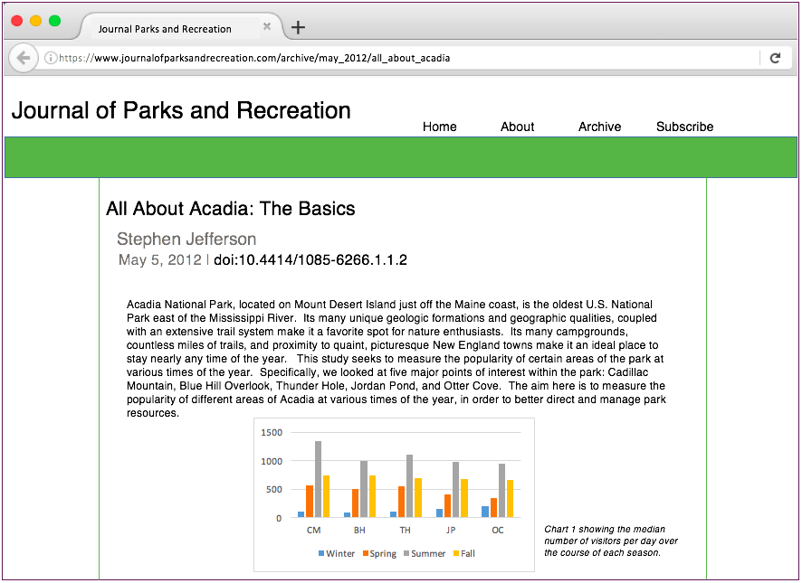

**Source is fictional**

Author

Year of publication

Article title